Click “File” 🡪 “Open” 🡪 “Examples” (just starting with a practice dataset)

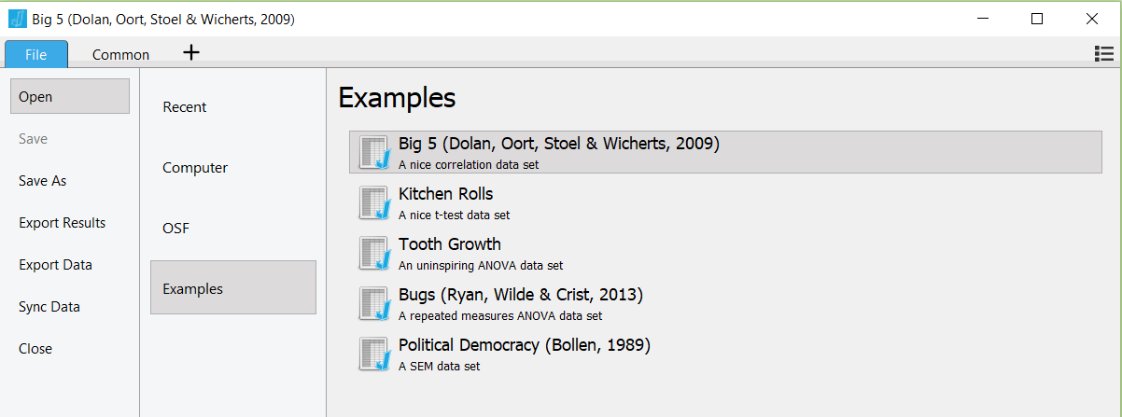

Click on “Big 5 (Dolan, Oort, Stoel & Wicherts, 2009)”

*Note: JASP opens a new window for every new dataset you open

Here’s the dataset we selected:

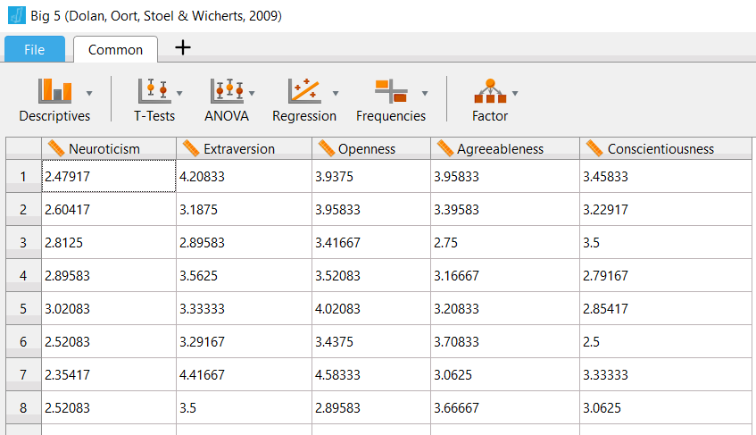

Click on “Descriptives” 🡪 “Descriptive Statistics”

Here’s what it pulls up:

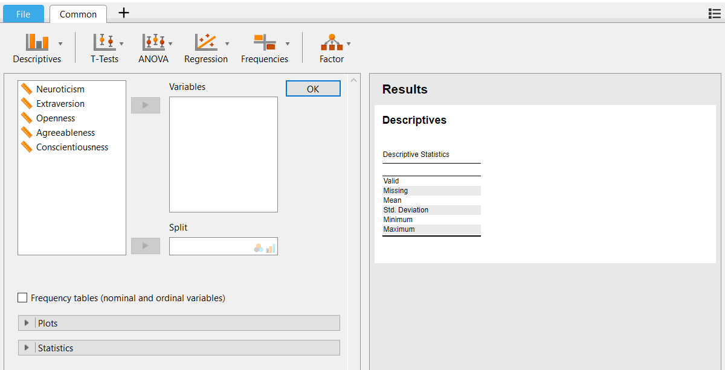

Select at least one variable (I just chose Conscientiousness) and click the arrow in the middle to move it to the “Variables” box.

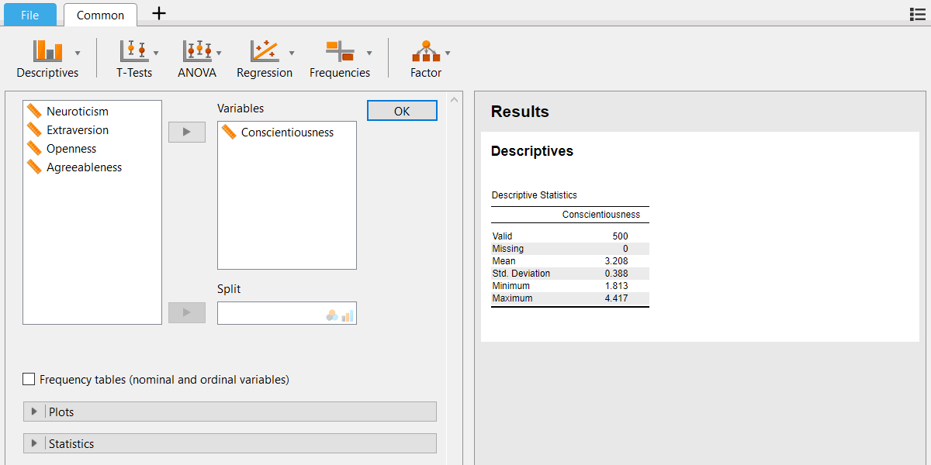

Click frequency tables button to get frequency tables (also in chapter 2)

Click the down arrow under “Plots” 🡪 Click the “Distribution plots” button

Histogram should appear on the right!

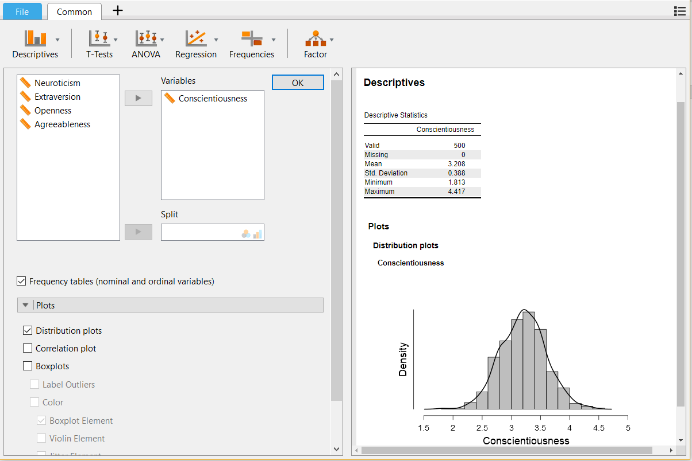

To save that nonsense, click on the down arrow by “Plots” in the window on the right:

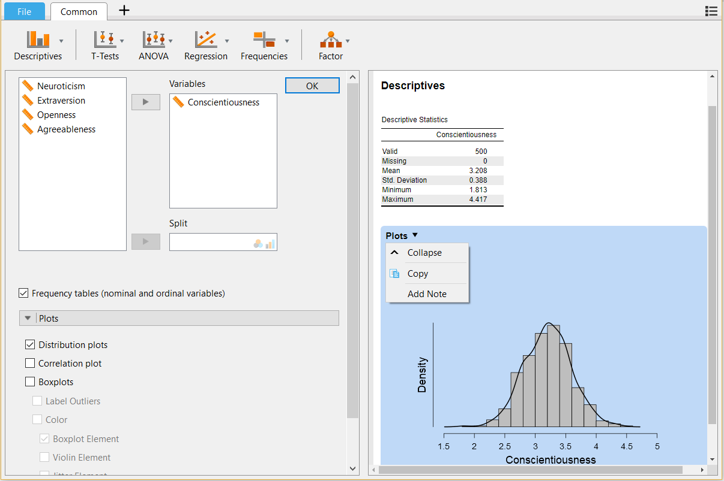

Click “Copy”

Go to Word and open new blank document

Click paste (I will probably have to add something here about mac copy paste which is weird).

**Plots**

**Distribution plots**

**Conscientiousness**

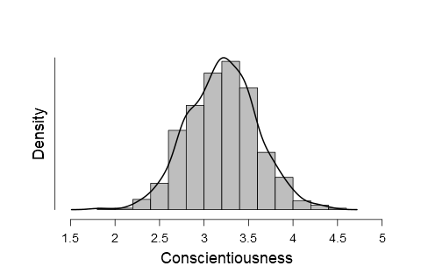

To see the analysis again (if you end up back in the data because you hit “OK”) just click on the analysis on the right hand side (somewhere in the blank space) to see the options you picked again:

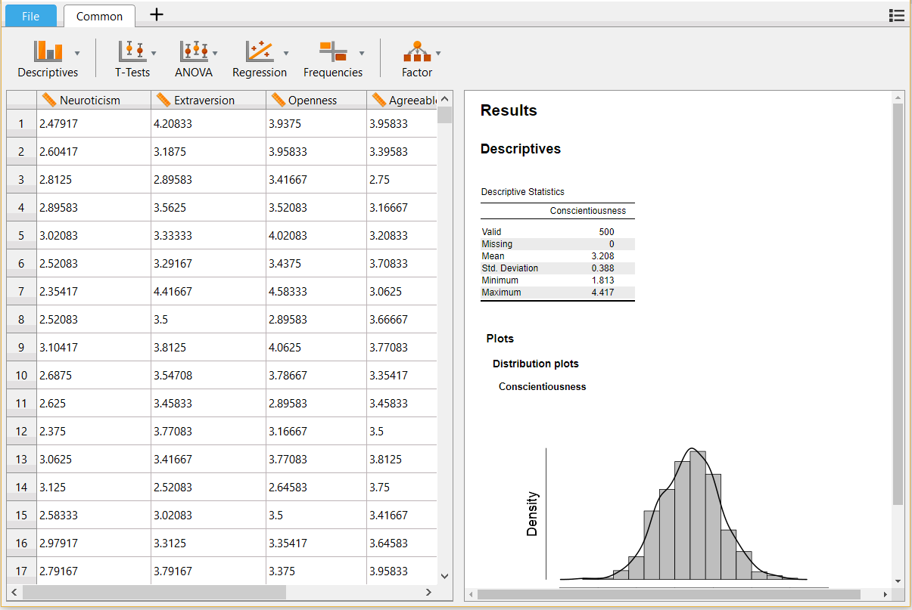

If you want to save what you’ve done you can save the file as “.jasp” which will open with jasp and will keep the exact analysis you saved. Go to “File” 🡪 “Save As” 🡪 “Computer” 🡪 “Browse”. Save it in your folder.

